Day 7 coding assessment
User story 1 output:
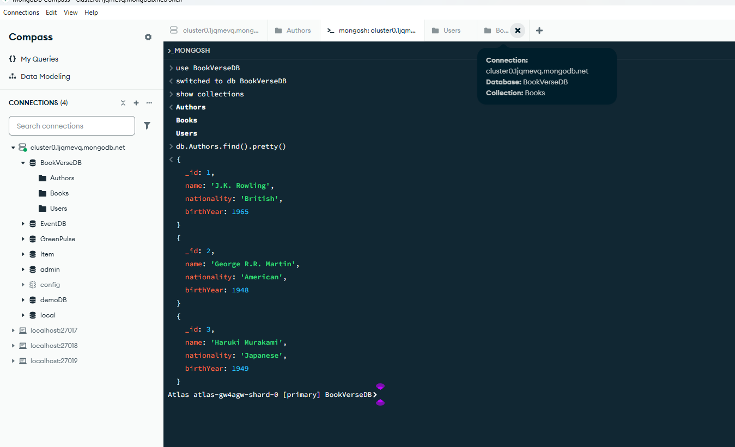
This screenshot output displays the database “BookVerseDB” is created with collections “Authors”, “Users” and “Books”. It also displays the data in “Authors” collection
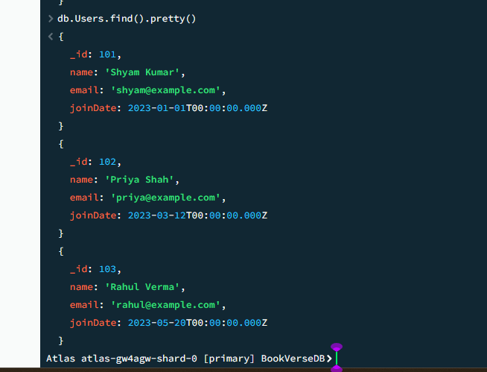
This screenshot output displays “Users” collection.
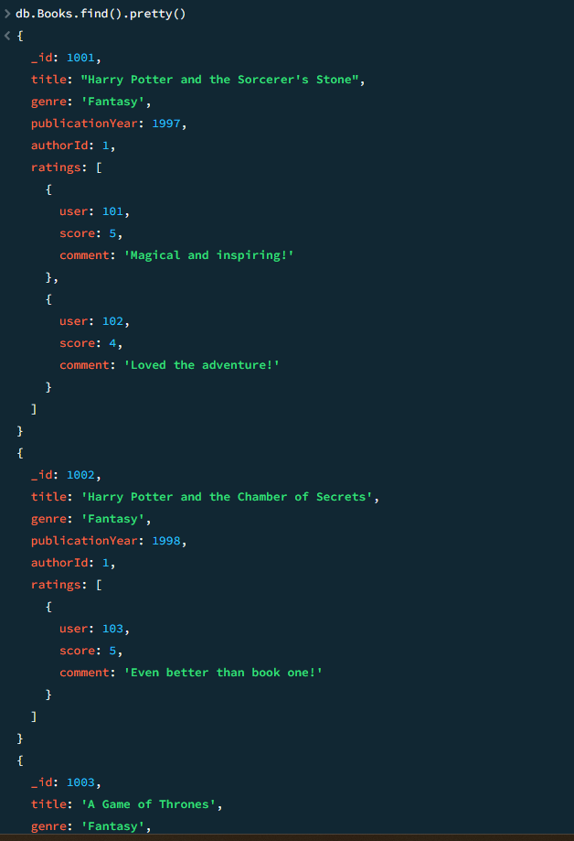

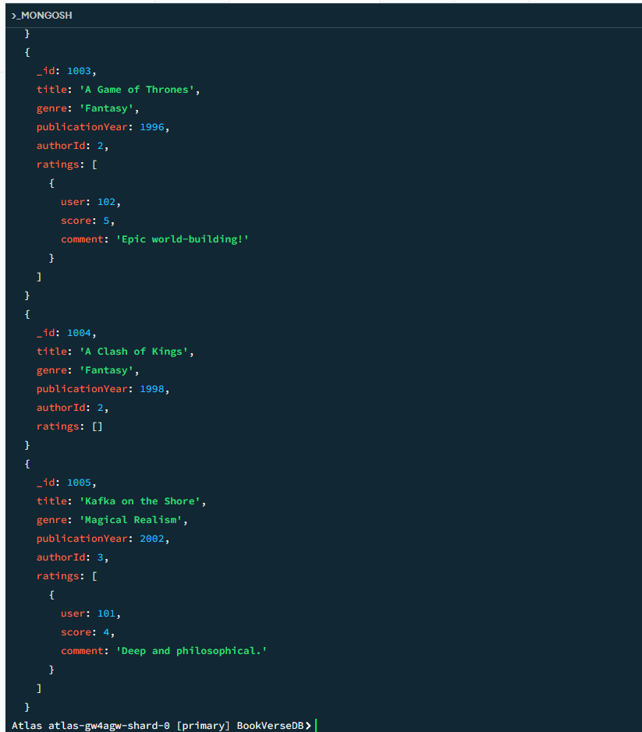
These two screenshots display the data in “Books” collection.

User story 2 output:
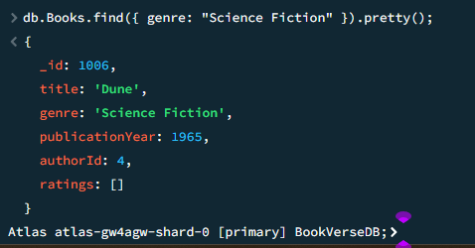

New book is inserted into the “Books” collection and it is retrieving books of the genre ‘Science Fiction’.

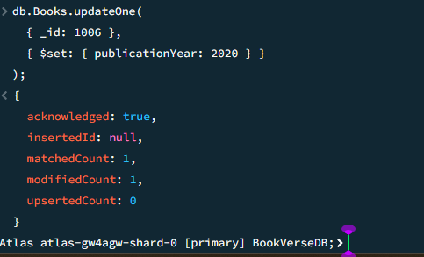
This output means the query successfully found the document (matchedCount: 1), but changes were made because the value was updated from (modifiedCount: 0) to (modifiedCount: 1).

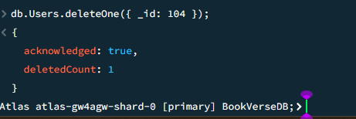
The User with id: 104 was deleted and the count was updated.

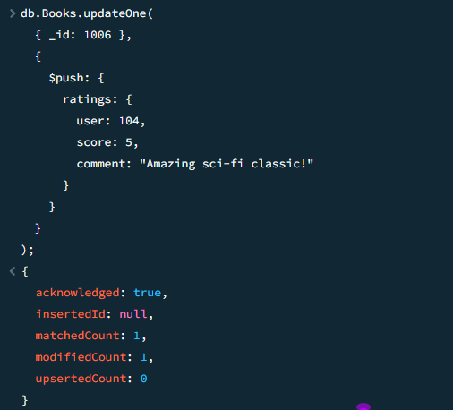
This output shows we successfully found out the book (matchedCount: 1) and added new rating, updating the document (modifiedCount: 1). No new record was created (upsertedCount: 0).

User story 3 output
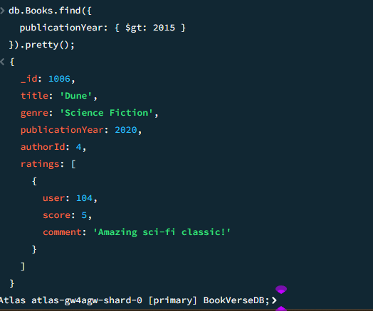
The books published after 2015 is displayed.

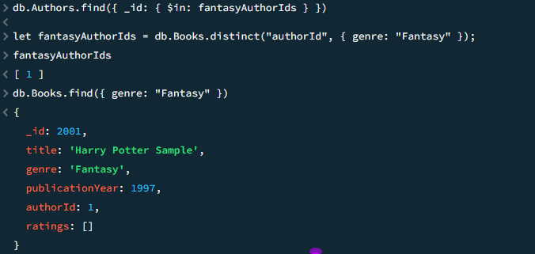
The book with fantasy genre

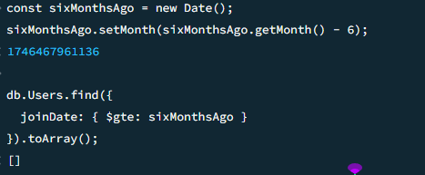
No user joined in the last six months.

